**Front-End UI/UX Mini Project**

**Project Submission Template**

**1. Title Page**

* **Project Title**: Responsive Homepage for a Local Bakery
* **Submitted By**: 
  + *Team Members- JEMIMAH ANNA ANIL, G. MONISHA REDDY, GOKUL SATHEESH*
  + *Roll Number: 2462080, 2462071, 2462074*
  + *College-E-mailid:*
  + [*jemimah.anna@btech.christuniversity.in*](mailto:jemimah.anna@btech.christuniversity.in)
  + [*gokul.satheesh@btech.christuniversity.in*](mailto:gokul.satheesh@btech.christuniversity.in)
  + [*g.monisha@btech.christuniversiy.in*](mailto:g.monisha@btech.christuniversiy.in)
* **Course**: *UI/UX Design Fundamentals*
* **Instructor Name**: *NARENDRAKUMAR GOPINEEDI*
* **Institution**: *Christ University*
* **Date of Submission**: *10/08/2006*

**2. Abstract**

*Example*:

This project focuses on the design and development of a professional and fully responsive website for a local business, specifically a bakery. The core goal was to establish a user-friendly online presence that effectively showcases the business's products and provides essential contact information. The project was built using **HTML5** for content structure and **CSS3** for all styling and responsive behaviors. The outcome is a clean, multi-page website that is fully functional across desktop, tablet, and mobile devices, adhering to modern UI/UX principles.

**3. Objectives**

The project goals are clearly defined as follows:

* **Structured Layout:** Design a clear and logical homepage structure using modern HTML5 semantic tags.
* **Aesthetic Styling & Responsiveness:** Apply CSS for comprehensive styling, including a consistent color scheme and a mobile-first design approach.
* **External Integration:** Successfully integrate external resources, such as a Google Maps iframe placeholder.
* **Accessibility & SEO:** Adhere to basic accessibility and SEO practices by using proper heading tags and descriptive alt attributes for images.

**4. Scope of the Project**

This project is focused exclusively on **front-end design and development**. It includes the creation of a responsive three-page website using only pure HTML and CSS. The project's boundaries are defined as follows:

* **Front-end only:** No JavaScript or server-side integration was included.
* **Viewport Compatibility:** The design is intended for desktop, tablet, and mobile viewports.
* **Open-source Tools:** The project used only open-source tools and pure code.
* **Local Assets:** All images and assets are stored locally within the project folder for fast loading and self-containment.

**5. Tools & Technologies Used**

|  |  |
| --- | --- |
| Tool/Technology | Purpose |
| HTML5 | Markup and content structure |
| CSS3 | Styling and layout management |
| VS Code | Code editor |
| Chrome DevTools | Testing and debugging |

**6. HTML Structure Overview**

* Used semantic tags: <header>, <nav>, <main>, <section>, <footer>
* Structured into reusable sections: About, Projects, Contact
* Navigation menu using <ul> and anchor links for smooth scrolling

**7. CSS Styling Strategy**

* Used external CSS file (style.css)
* Organized with comments and sections
* Techniques used:
  + Flexbox and Grid for layout
  + Media Queries for responsiveness
  + CSS Variables for theme customization
  + Hover effects and transitions
  + Mobile-first design approach

**8. Key Features**

|  |  |
| --- | --- |
| Feature | Description |
| Responsive Design | Adapts seamlessly to all screen sizes |
| Smooth Navigation | Fixed top nav with anchor links |
| Project Cards | Flex-based layout with hover effects |
| Contact Form (non-functional) | Placeholder layout for inputs and button |
| Location Map | An embedded Google Maps iframe helps users easily find the business's physical location. |

**9. Challenges Faced & Solutions**

|  |  |
| --- | --- |
| Challenge | Solution |
| Layout Issues | Difficulty in creating a flexible three-column layout. **Solution:** Shifted from outdated float methods to using **Flexbox** to handle the service-container and contact-section layouts. |
| Responsive Design | Elements and text were not scaling correctly on smaller devices. **Solution:** Implemented **media queries** to adjust font sizes, margins, and padding at different breakpoints, ensuring a consistent design. |
| Image Paths | mages were not loading after moving local files. **Solution:** Carefully reviewed and corrected all image source (src) attributes and CSS url() paths, paying close attention to relative folder structure (../images/). |

**10. Outcome**

* Achieved a clean, consistent, and visually engaging front-end layout
* All key components function as intended using just HTML and CSS
* Learned about layout responsiveness and UI hierarchy in depth

**11. Future Enhancements**

* Add JavaScript for interactivity (form validation, dynamic content)
* Integrate animations or transitions
* Backend integration for form submission
* Theme toggler (light/dark mode)

**12. Sample Code**

* *(Insert 2/3 screens code of the project with captions)*

**13. Screenshots of Final Output**

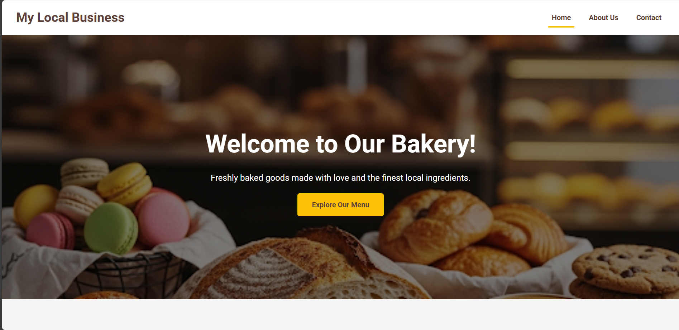

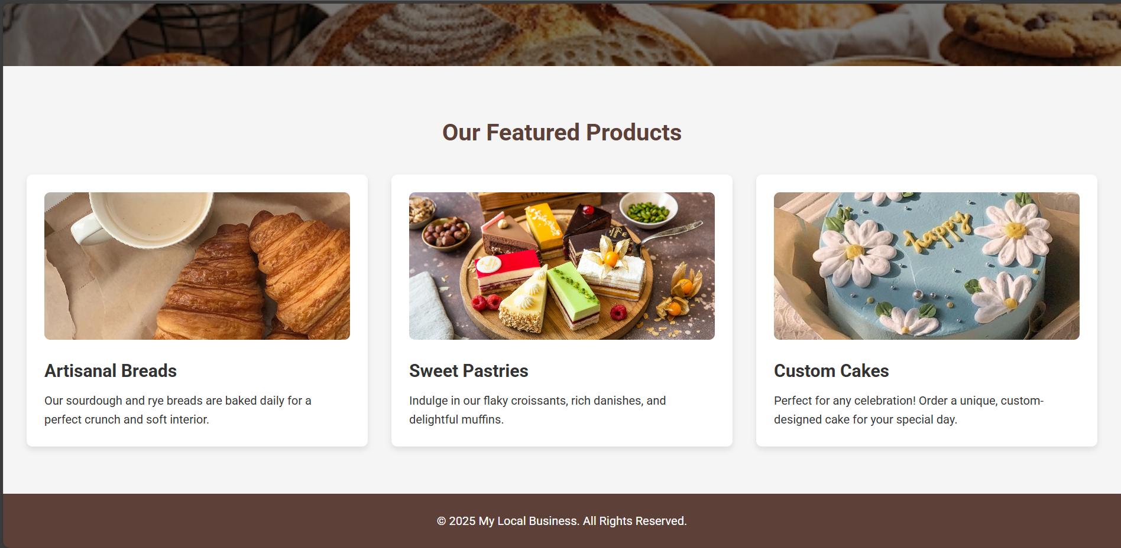

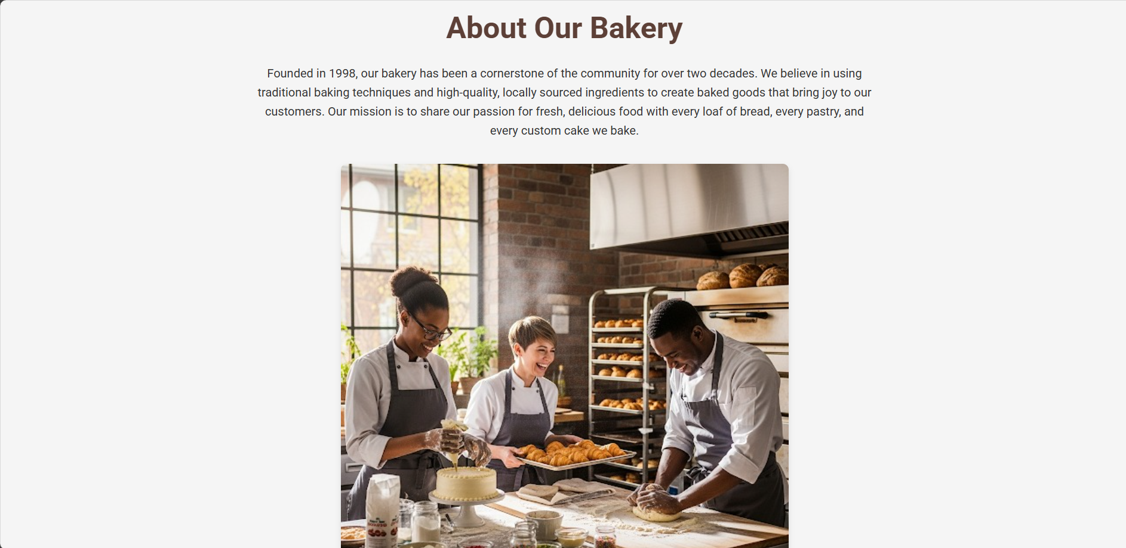

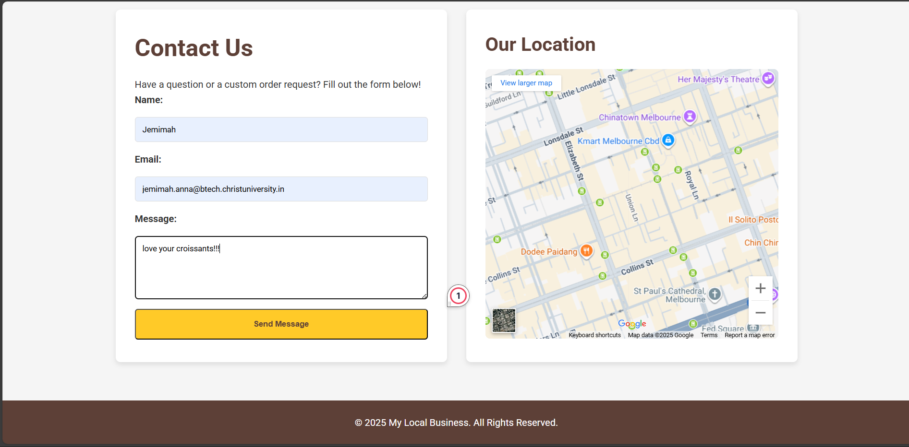

**14. Conclusion**

This project successfully delivered a multi-page, responsive website for a local bakery, serving as a valuable mini-project to strengthen front-end development skills. By using only HTML and CSS, I gained practical experience in responsive design, semantic layout structuring, and applying aesthetic principles. The hands-on implementation of UI/UX concepts enhanced my understanding of creating user-centric and accessible web designs.

**15. References**

* L&T LMS: https://learn.lntedutech.com/Landing/MyCourse